## **GENDER PAY GAP INFORMATION 2022-23**

## **Introduction**

The Equality Act 2010 (Gender Pay Gap Information) Regulations 2017 apply to all employers with 250 or more staff, and as such impact on RBGE.

Gender pay reporting legislation requires employers to publish statutory calculations every year showing how large the pay gap is between their male and female employees. RBGE adheres to these requirements.

Following the legislative requirements, and we confirm that data reported is accurate. All staff who were deemed to be full pay relevant employees have been included in the calculations. Full-pay relevant employees are all employees employed on your snapshot date who are paid their usual full basic pay and excludes employees on:

* maternity, paternity, adoption, parental or shared parental leave
* sick leave
* special leave

Both mean and median pay gaps are calculated as the percentage difference in female pay compared to male pay. The mean is the total salary of men / women divided by the number of men / women respectively. The median is the salary of the middle-ranked woman compared to the middle-ranked man across all pay grades when the salaries are arranged in order.

The data required to be published is as follows:

1. percentage of men and women in each hourly pay quarter.
2. mean (average) gender pay gap using hourly pay.
3. median gender pay gap using hourly pay.
4. percentage of men and women receiving bonus pay.
5. mean (average) gender pay gap using bonus pay.
6. median gender pay gap using bonus pay.

## **Gender Pay Gap at the Royal Botanic Garden Edinburgh**

The current gender pay gap results for RBGE is set out in Tables 1 to 4 at Appendix 1 and has been derived from salary information excluding overtime as of 5 April 2022. It should be noted that no bonuses are paid to any of our staff and therefore there is no data to be made available.

At the snapshot date of 5 April 2022, we employed 122 men and 163 women, making approximately 34% more women than men in employment with us.

The mean hourly pay for men among our staff is £18.13 and for women it is £16.66. The current mean gender pay gap for all staff across our published pay is therefore £ 1.47 or 8.1% in favour of men. The median hourly pay rate for men is £15.42 and for women it is the same at £15.42. The median gender pay gap is therefore £0 or 0%.

As no member of staff receives a bonus then this does not distort either the mean or median figures.

Signed by the Regius Keeper

|  |  |  |  |  |  |  |  |  |  |
| --- | --- | --- | --- | --- | --- | --- | --- | --- | --- |
| **Appendix 1** | |  |  |  |  |  |  |  |  |
| **Table 1** |  |  |  |  |  |  |  |  |  |

**Table 2**

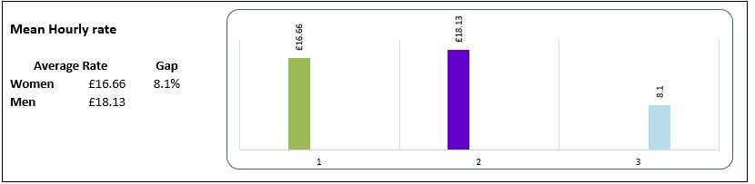

**Table 3**

**Table 4**

