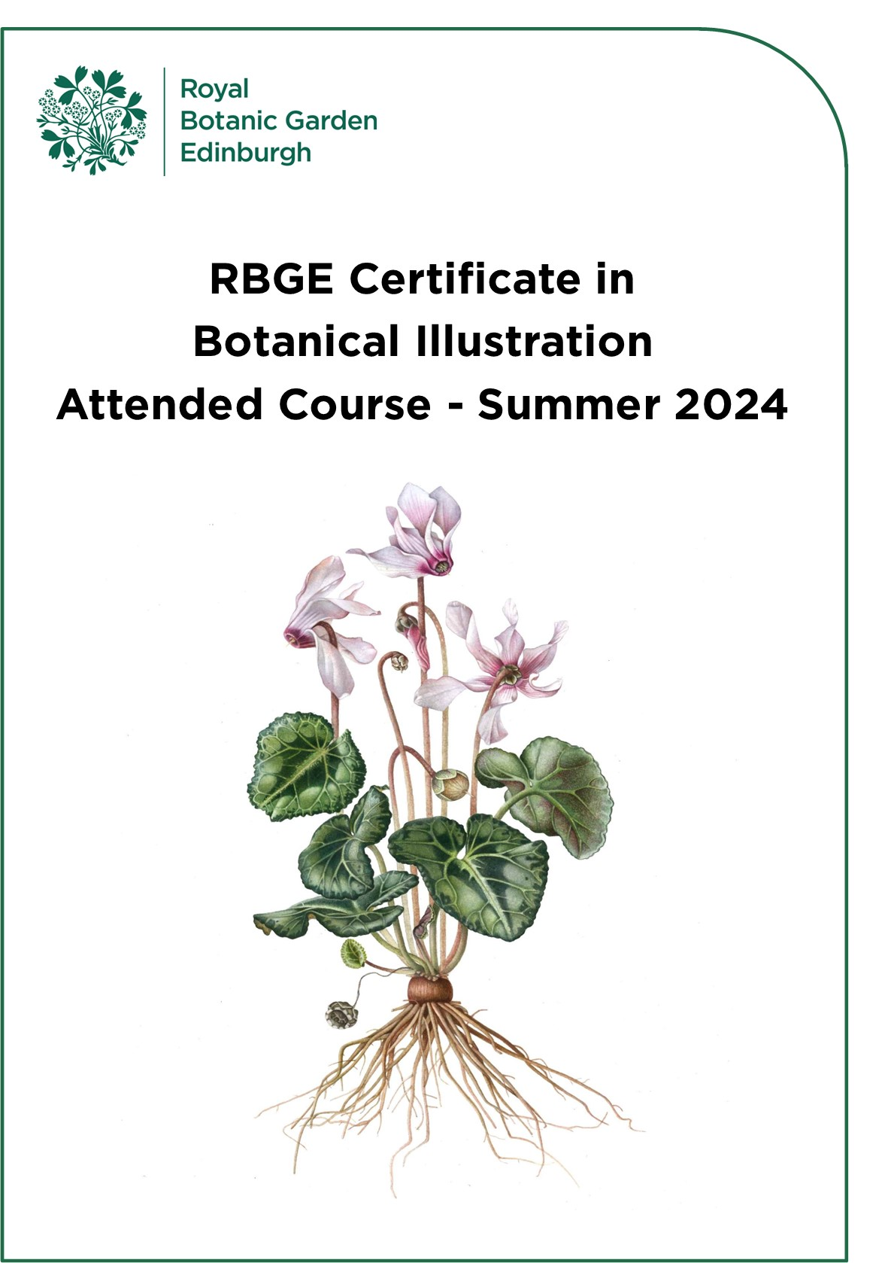RBGE Certificate in Botanical Illustration
Contents

1. Course Overview 3

2. Dates and Times for 2024 4

3. Unit Descriptors 4
Unit: CBI-01 5
Unit: CBI-02 6
Unit: CBI-03 7
Unit: CBI-04 8
Unit: CBI-05 9
Unit: CBI-06 10
Unit: CBI-07 11
Unit: CBI-08 12
Unit: CBI-09 13
Unit: CBI-10 14

4. Assessment Methods 15

5. Absence Procedure 18

6. Course Venue 18

7. Equipment Required 19

8. Course Fees 20

9. Application Procedure 20

10. Terms and Conditions 21

Cover image: A. Keiri

1. Course Overview

The RBGE Certificate in Botanical Illustration (CBI) is a great way to learn the fundamental techniques of paint and pencil. Using plants as our core subject this course is an ideal starting certificate if you want to become a botanical illustrator. The techniques you learn are valuable across all areas of illustration and seldom taught in art colleges or university art departments, so it is well suited to any developing artist.

There are many courses that teach botanical illustration, but this structured 10-day course consists of ten full-day taught units with assessment built into the programme within a standard framework. The focus is on the fundamental skills and is taught by experienced and enthusiastic tutors.

There is some theory provided to aid your understanding (in the form of short, highly visual presentations), but the course is designed to be delivered and assessed using a predominantly practical approach.

The RBGE Certificate in Botanical Illustration is a formally assessed course and therefore requires students to successfully pass assignments in order to achieve the award. Students are required to build up a course portfolio containing notes, visuals, and exercises. This body of work will show progression and help develop skills leading to a final painted composition. Both the portfolio and the final piece will be assessed, and the marks combined to provide the final grade. There is also an element of continuing self assessment and evaluation within the programme.

RBGE Diploma in Botanical Illustration

This course gives you all the skills required to apply for the RBGE Diploma in Botanical Illustration if you wish to take your studies to a professional level. Further details on the diploma can be found by visiting our website: www.rbge.org.uk/dipbi

2. Dates and Times for 2024

The CBI programme will be delivered at Royal Botanic Garden Edinburgh as a
ten-day block course over two weeks this summer. The days run from 10.00am to 4.00pm. Students who attend all ten sessions and successfully complete the assessments are awarded the RBGE Certificate in Botanical Illustration.

Unit Number | Title | Date
CBI-01 | Context of Botanical Illustration and Drawing Exploration | Monday 8 July 2024
CBI-02 | Drawing – Texture & Tone | Tuesday 9 July 2024
CBI-03 | Modelling in 3D with paint | Wednesday 10 July 2024
CBI-04 | Colour and Mixing Paint | Thursday 11 July 2024
CBI-05 | Botany | Friday 12 July 2024
CBI-06 | Practice - Flowers and Leaves | Monday 15 July 2024
CBI-07 | Introduction to Composition | Tuesday 16 July 2024
CBI-08 | Working on final Composition – Flowers and buds | Wednesday 17 July 2024
CBI - 09 | Working on final Composition – Leaves | Thursday 18 July 2024
CBI - 10 | Working on final Composition – roots, sections, final hand-in | Friday 19 July 2024

3. Unit Descriptors
Descriptors for all units are on the following pages. Each descriptor states the:
- Learning Objectives
- Key Knowledge and Practical Activities to be covered during the unit
- Assessment Guidelines

Unit: CBI-01
Context for Botanical Illustration & Drawing – Line and Measuring

Learning Objectives:
At the end of this Unit students will be able to:
- Understand the discipline of Botanical Illustration.
- Be familiar with the materials of the Botanical Illustrator
- Understand the key structures of the subject through investigation and simple line drawings.
- Understand the basic principles for accurate measured drawing

Key Knowledge:
- Use the drawing materials of the Botanical Illustrator.
- Understand the basic principles for accurate measured drawing.
- Demonstrate how to measure the correct size of the plant parts with correct scale and proportions.
- Understanding of the key structures of the subject through investigation, and simple line drawings

Key Practical Activities:
- Exploration of pencil line techniques
- Practicing key measuring skills
- An accurate measured observational drawing of a fruit and a leaf

Assessment:
- Student self-assessment
- Annotations of materials and methods used

Unit: CBI-02
Drawing – Texture & Tone

Learning Objectives:
At the end of this Unit students will be able to:
- Carry out a range of different techniques in pencil
- Understand the use of tone for 3D rendering
- Understand the techniques for rendering appropriate texture

Key Knowledge:
- Getting to know different pencil strengths appropriate for task
- How to create three dimensional illustrations
- Learn exactly what type of drawing is appropriate for the purpose (sketching, accurate line or tone)
- Reinforcement of measuring skills

Key Practical Activities:
- Exercises in tonal pencil
- Carry out a 3D pencil drawing of a fruit
- Explore various aspects of a leaf, front and back

Assessment:
- Student self-assessment
- Annotations of materials and methods used

Unit: CBI-03
3D Modelling with Paint

Learning Objectives:
At the end of this Unit students will be able to:
- Mix a variety of tertiary colours
- Build up depth of tone appropriate to the subject
- Use different methods to create detail

Key Knowledge:
- How to mix good tertiary colours
- Building up depth of tone in a controlled way
- Different methods to create detail
- Render the subjects in 3 Dimensions

Key Practical Activities:
- Tertiary colour mixing
- Creation of 3D shapes
- Transfer of drawing
- Application of paint

Assessment:
- Student self-assessment
- Annotations of materials and methods

Unit: CBI-04
Painting in True Colour

Learning Objectives:
At the end of this Unit students will be able to:
- Understand the principles of primary colour mixing
- Apply paint with the appropriate technique
- Understand how to bring a subject to a conclusion

Key Knowledge:
- Proportions of paint to water
- To learn control of paint
- Creating 3D form

Key Practical Activities:
- Colour Charts
- Primary Colour Wheel
- Further dry brush technique
- Colour matching fruit and foliage

Assessment:
- Student self-assessment
- Annotations of materials and methods

Unit: CBI-05
Botany

Learning Objectives:
At the end of this Unit students will be able to:
- Identify basic floral parts and their functions, in order to record the plants correctly
- Create and draw a cross section of a flower
- Understand how to convey scale
- Utilise a camera for recording accurately all the plant details

Key Knowledge:
- Appreciation of structure of flower head and its function
- Understanding of section depictions and scale conventions
- Identification of important and relevant parts of the plant
- Appreciation of the work of other botanical artists

Key Practical Activities:
- Becoming familiar with the final project brief
- Learning the basic botany of the plant subject
- Learn to dissect the flower and create a drawing
- Looking critically at botanical art from the context of your studies

** Introduction to Final Composition Brief will be given **

Assessment:
- Student self-assessment
- Annotations of materials and methods

Unit: CBI-06
Exploring your plant – Leaves and Flowers

Learning Objectives:
At the end of this Unit students will be able to:
- Identify basic structure and parts of leaves and flowers
- Draw and paint subject to a life-like standard
- Accurately match the colours of all plant parts
- Create a storyboard to plan a composition

Key Knowledge:
- Building on the skills of the previous units
- Practising colour matching
- Practising painting techniques
- Assembling work produced by different approaches
- Organising one’s time with reference to the life of the plant

Key Practical Activities:
- To colour test and mix relevant colours
- Investigate the subject through drawing and painting
- Learn the importance and use of Story boards

Assessment:
- Student self-assessment
- Annotations of materials and methods

Unit: CBI-07
Composition

Learning Objectives:
At the end of this Unit students will be able to:
- Arrange elements aesthetically
- Use sketches to help create a balanced composition
- Create a measured drawing of each part and combine into a convincing whole
- Transfer a drawing onto watercolour paper

Key Knowledge:
- View scientific and contemporary painting styles and consider how they differ
- Explore and understand how to create an interesting composition
- Create a measured drawing of the composition
- Transfer the drawing to watercolour paper

Key Practical Activities:
- Use of an appropriate method to transfer the drawing to watercolour paper
- Develop composition to conclusion

Assessment:
- Student self-assessment
- Annotations of materials and methods

Unit: CBI-08
Working on the Final Composition – Flowers and Buds

Learning Objectives:
At the end of this Unit students will be able to:
- Understand colour weight and balance, and the relationships between the elements of a composition
- Depict the flowers and buds to a high standard of finish
- Understand how to create depth of field in a painting

Key Knowledge:
- Importance of refining the composition
- Gain confidence with colour mixing and matching
- Continue exploration of paint application
- Control and use of materials

Key Practical Activities:
- Identifying correct colour balance for flowering parts
- Continue to work on the painting of the three elements
- Exploring details and challenging areas

Assessment:
- Student self-assessment
- Annotations of materials and methods

Unit: CBI-09
Work on Final Composition - Leaves

Learning Objectives:
At the end of this Unit students will be able to:
- Assess areas requiring more work
- Adjust work to increase depth of field
- Depict surface pattern
- Render overlaps convincingly

Key Knowledge:
- Balancing the composition
- Creating convincing spatial relationships between elements
- Understanding atmospheric depth

Key Practical Activities:
- Reinforcement of colour mixing techniques
- Exploring depth and overlapping subjects

Assessment:
- Student self-assessment
- Annotations of materials and methods

Unit: CBI-10
Finalising and hand in of all course work - Roots, sections, and hand in

Learning Objectives:
At the end of this Unit students will:
- Have knowledge of the application of finishing techniques
- Know when your painting is finished
- Be able to depict roots
- Be able to transfer knowledge and skills gained to other pieces of work

Key Knowledge:
- Assessment of coursework so far and completion of any outstanding work
- Investigation of areas for future work and development
- Awareness of when to add additional elements

Key Practical Activities:
- Complete final composition and any outstanding course work
- Drawing roots
- Decide on the inclusion of additional elements

Assessment:
- Student self-assessment
- Annotations of materials and methods

4. Assessment Methods

This is a predominantly practical course, designed to assess a practical level of understanding and competence. Candidates will be assessed in three ways:

4.1 Course Portfolio (35% of assessment marks)

You will be issued with a blank folder which you must then use to record the key knowledge points and all exercises from each unit, as well as the practical activities demonstrated and carried out during the course.

You are encouraged to include detailed notes, self analysis, diagrams, possibly photographs, labels and/or other information given to you during the course units. However, this is a ‘practical’ course and therefore you will be engaged for the most part in ‘hands on’ drawing and painting. The aim is that this is a working portfolio to which you can refer in the future, and will become an important part of the course.

After Day 4, tutors will carry out an interim review of the Portfolio.

All students must submit their Course Portfolio on the last day of the course for assessment.

4.2 Self-Assessment throughout the course including student Self-Assessment Chart (15%)

Each student is required to fill in a self-evaluation record at the end of each day of teaching. This is to enable the tutors to gauge your own understanding of progression during the course.

4.3 Working through Storyboard to achieve Final Composition (50%)
Days 5-10

Using provided plant samples, students and tutors will discuss and experiment with compositional approaches and select the final composition to be used.

Beginning with pencil studies, the proposed image composition is agreed and transferred onto the final watercolour paper and the process of painting from base washes to fully rendered state follows.

Students are required to present their work, demonstrating that they have been able to meet the set criteria, given at the start of the course.

A level of skill, in association with the assessment criteria, is required to pass this course.

Final Day

On this day there will be completion and hand in of the Final Composition and Portfolios with the completed self-assessment charts. There will also be a group review of all the final painted compositions.

This is an essential undertaking and will also provide the students with advice and guidance for their future development.

Grading will consist of -
- An assessment of the course units through your portfolio of work
- An assessment of your final composition
- Analysis of your Student Assessment Chart
- Written tutor feedback to students.

4.4 Certification & Grading

Successful candidates will be awarded the ‘RBGE Certificate in Botanical Illustration’, which will be graded as follows:

- Referral: 49%
- Pass: 50%-59%
- Merit: 60%-69%
- Distinction: 70% and above

NB: Referred candidates may retake the Final Composition Assessment but will only be able to gain a Pass.

The Course Portfolio will count for 35% of the final course mark, the botany and the Student Self-Assessment throughout the course (including the Self-Assessment Chart) 15%, and the Final Composition 50%.

4.5. Common Themes

The following themes will be considered throughout all the modules.
- Observation
- Drawing with precision
- Materials and equipment
- Painting techniques
- Composition
- Sourcing information
- Understanding plants
- Keeping a portfolio
- Presentation of work

5. Absence Procedure

If you miss a class or are unable to attend, you need to tell us as soon as possible. It may be possible to arrange for a catch-up day, there would be a fee of £150* for this, except under exceptional circumstances and by prior arrangement with RBGE.

If you are unable to attend a class or miss a class, please contact the Education Office in the first instance by emailing: botanicalart@rbge.org.uk

*If more than one student is attending the catch-up day this fee will be reduced accordingly.

6. Course Venue

Courses are taught at RBGE. Access is via main reception at 20a Inverleith Row, Edinburgh, EH3 5LR. Joining instructions telling you exactly where to come and how to get here will be issued upon acceptance of your space on the course.

Please contact us if you have any special access requirements.

7. Equipment Required

This is a practical course so you must have basic drawing and painting materials: This includes:

Art Materials
- A4 drawing paper pad
- Hot Press Watercolour paper: At least 3 sheets of 300 gsm paper A2 or A3 size or local equivalent (such as Saunders Waterford Hot Press (HP) watercolour paper)
- Artists Quality Watercolour Paints (such as Windsor & Newton Professional Quality Watercolour Paints) in the following colours:
- Permanent Rose
- Perylene Maroon
- Transparent Yellow
- Windsor Lemon
- Indanthrene Blue
- Cobalt Blue
*Further colours may be necessary depending on plant chosen for final project.
- 2B, HB, 2H pencils
- Ceramic palette or white plate for mixing paint
- High quality pointed watercolour brushes size 0, 2 and 4 (these are not required until Unit 03)
- Eraser – Plastic and Putty, a pencil-style eraser may also be useful (such as the Tombow Mono zero)
- Sharpener / knife
- 20/30cm clear Ruler and / or dividers
- Magnifying glass
- A “Pocket” microscope is also recommended

8. Course Fees

The cost for the course is £775. Full payment for the course is required on acceptance of a place.

9. Entry Requirements

This course is suitable for complete beginners. Although there are no formal entry requirements, it is important to note that this course will require some home study during the weekend. How much home study will depend on your existing level of experience.

10. Application Procedure

Spaces on this course are limited. Candidates will be selected on the basis of the answers given to the questions on the application form. If all applications are of a high standard, applications may be allocated based in the order they were received.

To apply for the course, you must complete the online application form.

Course | Applications Open | Applications Close
Summer 2024 | Monday 15th April 2024 | Monday 27th May 2024

Applications will open at 9.00am on the first day and close at 5.00pm on the last day. These times are UK times, please take this into account if applying from outside the UK.

Applicants will be notified if their application has been successful or not within 2 weeks of the application deadline date.

11. Terms and Conditions
- RBGE reserves the right to cancel this course
- RBGE cannot be liable for additional costs incurred in the event of cancellation
- If the course does not go ahead, any money paid to the RBGE would be refunded in full
- Fees will not be refundable should you not complete or pass the course.

What if I change my mind? (Refunds)
You will receive a refund minus a £50 administration fee if you withdraw from the course prior to more than two weeks before the course begins.
If you wish to withdraw from the course, you must inform us of your decision by email. Cancellation by email is effective from the date on which you send us your message.
Attended Courses: We will be unable to offer a refund after the start of the course.

Privacy Notice
RBGE will process your personal data for the administration of your course, to create your account on PropaGate Learning and to take payment (where relevant). RBGE will also process your personal data to inform you of any updates to the course, the admissions procedure, course dates, as well as any special offers. For more information see our privacy notice.

