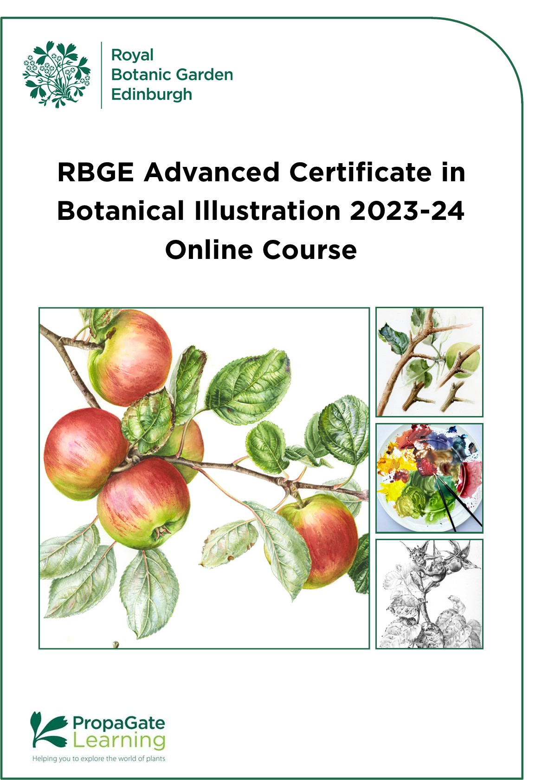

RBGE Advanced Certificate in Botanical Illustration 2023-24 Online Course
Contents

1. Course Overview 3
2. Course Structure and Dates for 2023 - 24 5
3. Course Content 6
4. Assessment Methods 10
5. Online Learning 11
6. Equipment Required 13
7. Course Fees 15
8. Entry Requirements 15
9. Application Procedure 16
10. Terms and Conditions 17
11. Appendix: Finding Your Plant Subject 18

1. Course Overview
The RBGE Advanced Certificate in Botanical Illustration (ACBI) is a great way to consolidate the techniques of paint and pencil and close observation of plants that you learned in the RBGE Certificate in Botanical Illustration. This course is designed to help foster your independent learning, take your knowledge, skills and confidence further, build your portfolio of botanical artworks and at the same time deepen your understanding of the special botanical view of plants.

Please note: This course is not for absolute beginners. If you are just starting Botanical Illustration, we advise you to consider taking the Certificate in Botanical Illustration instead.

This course consists of three units, with a submission at the end of each.
Students will be creating an original painting of a fruiting or flowering branch of a plant. They will select a specimen to work with over the course in the one of the plant families Rosaceae, Malpighiaceae, Theaceae or Rutaceae and work with this species throughout. We will be working with live plant materials so each student must have access to suitable plant material. (For suggestions see Appendix below.) The course is 13 weeks long.

Feedback and tutor support will be provided after each submission. Self–directed work is important to this course, and we also encourage you to participate in the class forum discussions to share the journey with your peers. The course is delivered and assessed entirely online through the Propagate site. Course materials include videos, galleries, and text, and students will be encouraged to do a little research outwith the course.
Please note there will be no face-to-face teaching, or live demonstrations on this course.

Students are required to build up a course portfolio containing notes, photos, sketches, paintings and drawings and to upload these to PropaGate Learning (RBGE’s online learning environment.) The RBGE Advanced Certificate in Botanical Illustration is a formally assessed course and therefore requires students to successfully pass all units in order to achieve the award.

Level of Study
This course is an extension of our Certificate course. It is aimed at people who have either successfully completed our Certificate with an award of Merit or Distinction, or to students with equivalent skills and experience. We expect applicants to have a good grasp of the fundamental skills of botanical illustration: an interest in botany, close observation, accurate drawing, colour matching and painting plant subjects to completion.
The pace of the course will be difficult if you do not have a good grasp of the fundamental skills of botanical illustration. In particular, you should be familiar with the concept of measured drawing and feel confident that you understand how to measure and draw plant subjects. You don’t have to be very confident in your skills but if you don’t know what these are please consider taking the Certificate in Botanical Illustration course instead.
The course is not a pre-requisite for joining the RBGE Diploma in Botanical Illustration, though you may find it valuable if you wish to develop your portfolio, gain confidence, and simply enjoy expanding your skills.

All information in this handbook is correct at the time of publication and is subject to change.

2. Course Structure and Dates for 2023-24
The online CBI programme will be delivered through PropaGate Learning as a three-unit course. Students who successfully complete all three units and the assessments are awarded the RBGE Advanced Certificate in Botanical Illustration.
The timetable below is included to demonstrate the pace of the course. The course can be very absorbing, and some activities may take longer than you expect! We advise that students need to put aside 10-12 hours per week for study.

It is extremely important that you keep to the study timetable to get the most out of this course. It means you will receive feedback at the appropriate times to enable you to continue smoothly with the course and successfully complete it.

If you are unable to complete a module in the specified timeframe, you must contact your tutor to discuss the options. There will be an additional charge for marking and feedback of late submissions.

Autumn Intake Timetable – overview
Unit | Title | Release Date
Start | Welcome and introductions | 28/09/23
ACBI-01 | Unit 1 Exploration | 05/10/23
ACBI-02 | Unit 2- Development | 16/11/23
ACBI-03 | Unit 3- Production | 07/12/23
End | Final Submission | 18/01/24

Spring Intake Timetable - overview
Unit | Title | Release
Start | Welcome and introductions | 25/04/24
ACBI-01 | Unit 1 Exploration | 02/05/24
ACBI-02 | Unit 2- Development | 13/06/24
ACBI-03 | Unit 3- Production | 04/07/24
End | Final Submission | 01/08/24

3. Course Content
Descriptors for all units are on the following pages. Each descriptor states the:
- Learning Objectives
- Key Knowledge and Practical Activities to be covered during the unit
- Assessment Guidelines
Unit ACBI-01: Exploration
Getting to know your plant

Learning Objectives:
At the end of this Unit students will be able to:
- Record special characteristics of their plant family (Rosaceae, Malpighiaceae, Theaceae or Rutaceae)
- Select suitable plant specimen to work with
- Undertake research on own study plant
- Make preliminary sketches and measured drawings and colour studies of their plant

Key Knowledge:
- Understanding of their plant within a botanical context
- Working with appropriate plant material
- Understanding their subject through investigation using painting and drawing
- Assembling preliminary materials in preparation for a final piece

Key Practical Activities:
- Research and contextualisation skills
- Exploration of pencil and watercolour techniques
- Creation of a portfolio of preparatory work

Assessment:
- Student self-assessment
- Annotations of materials and methods used
- Upload of coursework

Unit ACBI-02: Development
Beginning work on the final piece

Learning Objectives:
At the end of this Unit students will be able to:
- assemble the relevant drawings to make a composition
- explore the possibilities for placing the elements on the page to tell a story about your plant
- Arrive at a well-balanced composition.

Key Knowledge:
- Making decisions about relevant information
- Assess compositional possibilities
- Adjust compositions to achieve balance in colour, tone and pictorial space.

Key Practical Activities:
- Transfer of selected drawings
- Manipulation of images within picture plane
- Successful creation of a composition that is ready to paint

Assessment:
- Student self-assessment
- Annotations of materials and methods used
- Upload of coursework

Unit ACBI-03: Production
Painting the composition and hand in

Learning Objectives:
At the end of this Unit students will be able to:
- Create a botanical illustration incorporating important botanical features of their special plant family (Rosaceae, Malpighiaceae, Theaceae or Rutaceae.)
- Paint the final composition in full colour to completion
- Transfer knowledge and skills gained to other pieces of work

Key Knowledge:
- Incorporation of key family characters into a botanical artwork
- Creation of a botanical painting for publication or exhibition online or in print

Key Practical Activities:
- Working through various stages to complete a botanical painting
- Finishing techniques
- Digital presentation of the completed work

Assessment:
- Student self-assessment
- Annotations of materials and methods
- Upload of coursework

4. Assessment Methods
This course is designed to build on and expand existing skills, understanding and competence to give students greater confidence and independence in their working methods. Candidates will be assessed at the end of the course on the following:
Units 1 and 2 – Course Portfolio: 40%
Unit 3 – Final Piece: 60%
You will be given tutor feedback after your submissions at Units 1 and 2 to help you progress. Your coursework and finished composition will be assessed at the end to give your final grades and feedback.

Certification & Grading
Successful candidates will be awarded the ‘RBGE Advanced Certificate in Botanical Illustration’, which will be graded as follows:
- Fail: 0% - 39%
- Referral: 40% - 49%
- Pass: 50%-59%
- Merit: 60%-69%
- Distinction: 70% and above

NB: Students who gained a mark of Referral may retake the Final Composition Assessment but will only be able to gain a Pass.

5. Online Learning
Your online learning environment is PropaGate Learning which uses the Moodle learning platform.

PropaGate Learning is the website that you log into to access your course. It is a place for learning and for discussing topics and progress with your tutors and other students. PropaGate Learning allows you to study from home, whilst becoming part of a thriving and enthusiastic learning community. Please note there will be no face-to-face teaching, or live demonstrations on this course.

Your course consists of a number of elements, including notes, videos, galleries, discussion forums, and an upload area for your drawings and paintings. The resources and activities are designed to help you learn online and to help you to share and learn from each other.

How can I prepare for studying online?
You should be a competent computer user with a basic understanding of standard computer applications such as using an internet browser, email and word processing. Your course involves uploading your drawings and paintings, so experience of scanning images using a scanner or taking good quality photographs of your artworks with a digital camera, and of editing/re-sizing images would be useful. Our Help and Support for Online Learning will help you to identify any areas of IT you may need to brush up on.

You will be given access to PropaGate Learning prior to the course starting to help you familiarise yourself with the online environment. Please make use of this time as it will enable you to fully engage with the course itself once it starts, rather than spending your time finding your way around. It is also a chance to meet other learners and the tutors.

Online courses require a much more self-motivated learning style than traditional attended classes. You should plan to set aside a certain amount of time to log into the course classes and carry out tasks. You will need to be proactive about understanding the timetable and submitting your work. Participation in online discussions and the sharing of work is also part of the course – online learning is much more sociable than you might think!

What hardware or software will I need?
- A computer with reliable online access (broadband capable of watching video online). Most of the module can be viewed on a tablet, however you may find a desktop/laptop computer easier for completing coursework.
- An up-to-date version of one of the following 3 browsers: Firefox, Google Chrome or Safari.
- A digital camera or good phone camera with tripod, or access to a scanner (A3 size flatbed scanner is ideal) to take good quality images of your artworks.
- A basic image manipulation package for reducing the size of images will be especially useful if you are taking pictures of your artwork with a camera (e.g. Microsoft Paint, Photoshop Elements, Preview for Mac)
- Software that will open PDFs (e.g., Adobe Reader).

The PropaGate Learning website is available 24/7 with the exception of any maintenance work, which we will inform you about in plenty of time.

What support is available?
We encourage everyone to make the most of the forums on the course. These provide a way for students to talk to one another and to ask tutors questions about the work. Tutors usually check the forums at regular intervals (e.g. once or twice a week). In emergencies, you will be able to contact your tutor privately.
Our PropaGate Learning team are always available so if you ever feel you are stuck with a course-related technical problem, they can be contacted via the forums or by emailing: propagatelearning@rbge.org.uk

6. Equipment Required
Art materials
- For drawing: A3 cartridge paper (called drawing paper in some parts of the world) such as Fabriano Accademia, Seawhite, Lambeth, Stonehenge drawing papers etc.

- For painting: Hot pressed watercolour paper, size A3 or larger. We recommend:
  - Saunders Waterford High White, HP 140lb/300gsm OR
  - Arches HP 300gsm OR
  - Stonehenge Aqua Smooth 300gsm OR
  - Canson Moulin du Roy HP 300gsm
  - Fabriano Artisico "Enhanced"
  - Other hot-pressed paper if none of above are available
- Tracing paper: two full sheets or pad

- HB, 2H, 3H pencils
- Pigment fineliner pen, the smallest nib size— 0.05
- Ceramic palette or white plate for mixing paint
- Eraser – Plastic and Putty
- Sharpener / knife
- 30cm clear Ruler and dividers
- Magnifying glass
- A hand lens or loupe, X10
- A “Pocket” microscope is recommended if you are working with a plant with small fruits. This should be x40-60 magnification - the one produced by the Natural History Museum, London, is ideal, although other brands are also available.
Watercolour paints

These must be “artists’ quality” or “professional” quality. Colours we particularly recommend are Winsor and Newton Professional Quality :
- Indanthrene Blue PB60
- French Ultramarine Green Shade PB29
- Permanent Rose PV19
- Winsor Red PR254
- Transparent Yellow PY150
- Winsor Lemon PY175

You can substitute other brands in similar colours. Daniel Smith, M. Graham, Schminke, Sennelier, Jacksons: check the labels to see if they contain the pigments you want.

You may also find you need other colours as the course progresses, depending on which plant you choose to paint for your final submission.

Watercolour Brushes
Good quality brushes are essential. Kolinsky sable brushes are strongly recommended. Your brushes should have rounded and pointed bristles. Winsor & Newton Series 7 miniature brushes in sizes 2 and 4 are highly recommended, as are the regular sized Series 7 brushes. Other good brands are quite acceptable, such as Da Vinci or Raphael.

If you need to use synthetic brushes, invest in the highest-quality artists brushes you can find. Manufacturers like Da Vinci, Princeton and Pro Arte are working hard to create adequate substitutes for sable brushes, but none of the synthetic brushes are as versatile as sables. So you will need a selection of soft and firm synthetic brushes in various sizes.

Cheaper synthetic brushes are also useful for mixing and some texture.

If you are buying directly from a shop, you should try to see if you can test out the brush before buying – most good art shops will let you do this.

7. Course Fees
The cost for the course is £495. Full payment for the course is required on acceptance of a place. Fees do not include the cost of any materials required to complete the course.

8. Entry Requirements
Entry for this course is restricted to applicants who have successfully completed RBGE’s Certificate in Botanical Illustration programme, and obtained a grade of Merit or Distinction or to others who have equivalent skills and experience.
It is important to note that this course will be delivered fully online and in English. A good understanding of the English language is required to get the most from the course and to enable you to succeed in your studies and You must be able to write in English when communicating with your tutor.

You should be a competent computer user with a basic understanding of standard computer applications such as using an internet browser, email and word processing. Your course involves uploading your drawings and paintings, so experience of scanning images using a scanner, taking photographs with a digital camera and of editing/re-sizing images will be useful. Our ‘Digital Skills Check’ will help you to identify any areas of IT you may need to brush up on.

9. Application Procedure
Spaces on this course are limited. Candidates will be selected on the basis of the answers given to the questions on the application form at the back of the handbook. If all applications are of a high standard, spaces will be allocated to people based on the date the applications were received.

Applications will only be open for one intake of the course at a time. To apply for the course, you must complete our online application form.

Course | Applications Open | Applications Close
Autumn Intake | Wednesday 5th July 2023 | Friday 18th August 2023
Spring Intake | Monday 22nd January 2024 | Friday 8th March 2024

Applications will open at 9.00am on the first day and close at 5.00pm on the last day. These times are UK times, please take this into account if applying from outside the UK.

Applicants will be notified if their application has been successful or not within 2 weeks of the application deadline date.

10. Terms and Conditions

RHS Courses and Online Short Courses
(where all resources are accessible immediately with no time constraint)

You will not be eligible to a refund if any of the learning materials have been accessed within the 14 days of payment (this does not include introductory resources but does include any e-books). If you have registered for two certificates, however you have only accessed one, a 50% refund will be given.

RBGE Diplomas and Certificates
Online Courses: You are eligible for a full refund within 14 days of payment, minus the value of the course available and accessed (e.g. if the course has 10 units and you have accessed one, you will receive 90% of the course fee as a refund).

Attended Courses: We will be unable to offer a refund after the start of the course.

Exercising your right to cancel
If you wish to exercise your right to cancel within the 14 days, you must inform us of your decision within the cooling off period. Cancellation by email or by post is effective from the date on which you send us your message.

Fees will not be refundable should you not complete or pass the course.

Privacy Notice
RBGE will process your personal data for the administration of your course, to create your account on PropaGate Learning and to take payment (where relevant). RBGE will also process your personal data to inform you of any updates to the course, the admissions procedure, course dates, as well as any special offers. For more information see our privacy notice.

11. Appendix: Finding Your Plant Subject
Throughout this course we expect you to work with live plant material wherever possible. Please do not work from photos!

You will need material including fruits or flowers from living plants in Rosaceae, Malpighiaceae or Rutaceae family. It does not matter if they are growing wild or cultivated, but please note that you will need some leaves and parts of the branches the flowers or fruits grow from. You will be studying the same species throughout the course, so please pick a subject that will last.

We have tried to find families that give worldwide coverage, including both cultivated plants and weeds, herbaceous and woody species - though you may not be able to find more than a few species in your area that are fruiting or flowering in your area. Depending on where you are, some commonly available plants might be:

Rosaceae
Apples, Pears, Plums, Quince, Geums, Roses, hawthorns, loquats, blackberries, Sorbus.
Malpigiaceae
West Indian Cherries, Stygmaphyllon, Caapi vine.
Rutaceae
Citrus plants - oranges, lemons, limes; the curry plant Murraya; Sichuan pepper.
Theaceae
Camellia, Stewartia.

If you do not have easy access to such plants, you could consider ordering a couple of plants from your local plant nursery or getting in touch with a local grower who will be happy to supply you with plant material. You need to keep your plant or plants alive for the duration of the remainder of the course, so it may be worth getting two or more.

We recommend that you do a bit of research on the conditions that it prefers and try to mimic them. For instance, if your plant typically grows in cool woodland conditions, it might be good to keep them in a cool room and only bring them into your painting space while you are actually working with them.

Rosaceae
The rose family is large and diverse, with almost 5000 species to choose from, including hundreds of familiar useful crops – mostly fruits and ornamental flowers.

Alchemilla – the lady’s mantles
Cotoneaster – the cotoneasters*
Crategus – the hawthorns*
Eriobotrya – loquat*
Fragaria – the strawberries
Malus – the apples*
Potentilla (and various other recently renamed genera) – the cinquefoils, tormentil, silverweed and many others.
Prunus – the cherries, plums, peaches and almonds*
Pyracantha – the firethorns*
Pyrus – the pears*
Rosa – the roses*
Rubus ­– the raspberries, blackberries and other bramble-like plants
Sorbus – whitebeams and rowans*
Spiraea and Filipendula – the meadowsweets and relatives (some of these are among the many plants called ‘goatsbeards’)*

*These are mostly woody, and therefore well suited to the project

There are many other interesting species as well, which have often found their way into cultivation such as the loquat (Eriobotrya) and so-called filo-pastry tree (Polylepis australis)

A list of the main groups (genera) in the family can be found here on Wikipedia you can find a more complete list here too, on Britannica.
For a complete listing and more detail on the species you are researching, you can visit the following:
World Flora Online – a huge online consortium about plant diversity

on the Plants of the World Online website.

GBIF Global Biodiversity information facility – used by researchers to pinpoint individuals or collections of plants, often including photos and maps

Malpighiaceae
Tropical family: most common and diverse in the Neotropics, many species are grown as ornamentals. Important plants include
Hiptage - the Hiptages
Galphimia gracilis- The Gold Shower
Malpighia emarginata and M. glabra - the Acerola or West Indian Cherries
Banisteriopsis caapi - Yage
Stigmaphyllon

A list of the main groups (genera) in the family can be found here on Wikipedia, you can find an overview here too, on Britannica.

For a complete listing and more detail on the species you are researching, you can visit the following: World Flora Online – a huge online consortium about plant diversity

or the Plants of the World Online website.

You will also find valuable information on GBIF Global Biodiversity information facility – used by researchers to pinpoint individuals or collections of plants, often including photos and maps

Rutaceae
The family's natural range is warm-temperate to tropical, though many species are cultivated worldwide
Citrus - The citrus fruits - oranges, lemons, kumquats, tangerines, grapefruits, pomelos etc.
Choisya - "Mexican Orange Blossom" - widely planted fragrant evergreen shrubs
Skimmia - another genus of widely cultivated evergreen plants
Zanthoxylum - the Sichuan peppers, prickly ash
Ruta - the bitter herbs known as Rue
Glycosmis pentaphylla - the Gin Berry or Orangeberry
Chloroxylon swietenia - the East Indian Satinwood, a tree with high-quality wood
Triphasia - the sweetlimes or limeberries
Aegle marmelos - the Bael or Bilwa tree

A list of the main groups (genera) in the family can be found here on Wikipedia, you can find a more complete list here too, on Britannica.
For a complete listing and more detail on the species you are researching, you can visit the following: World Flora Online – a huge online consortium about plant diversity
or the Plants of the World Online website.

You will also find information about this family on GBIF Global Biodiversity information facility – used by researchers to pinpoint individuals or collections of plants, often including photos and maps

